INCLUDE:

HOME

ABOUT

SKILLS

ART WORK

CONTACT

……

<http://www.adamhartwig.co.uk/>

 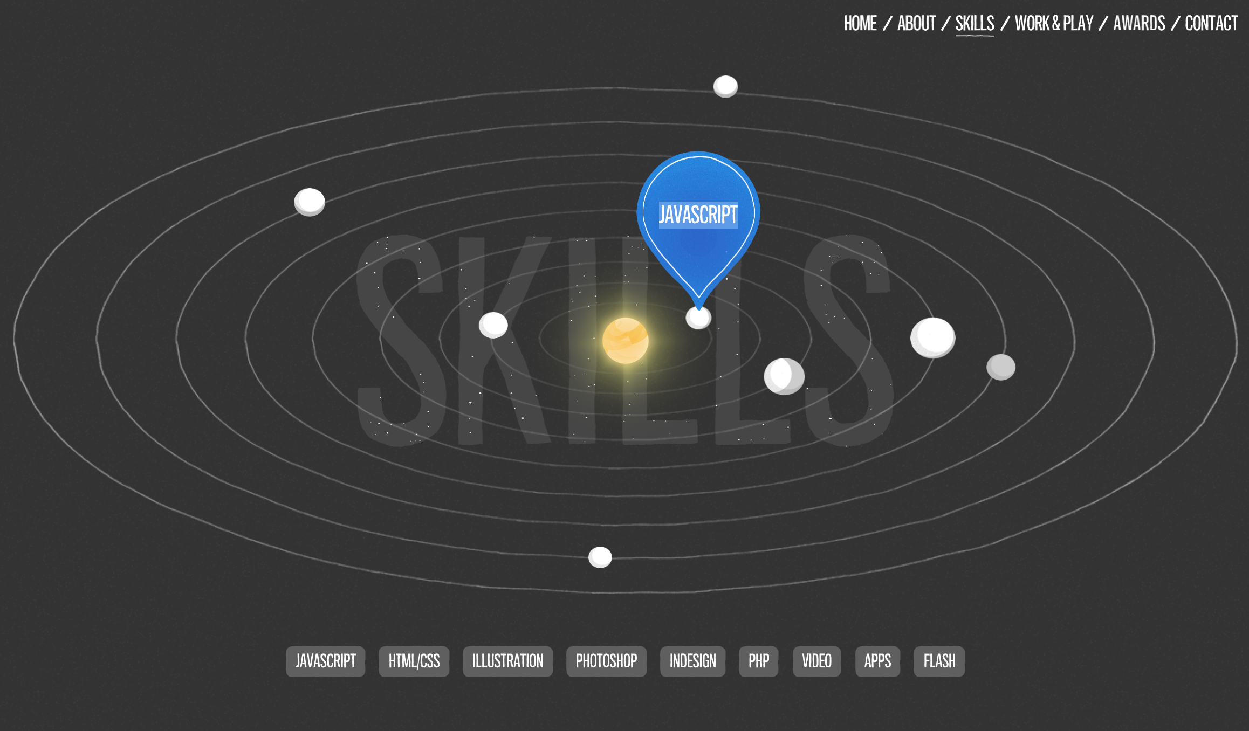

The interactive illustrations and bright colors on this website make the whole thing interesting. I like the style of this site.

<http://www.fiftycoffees.com/>

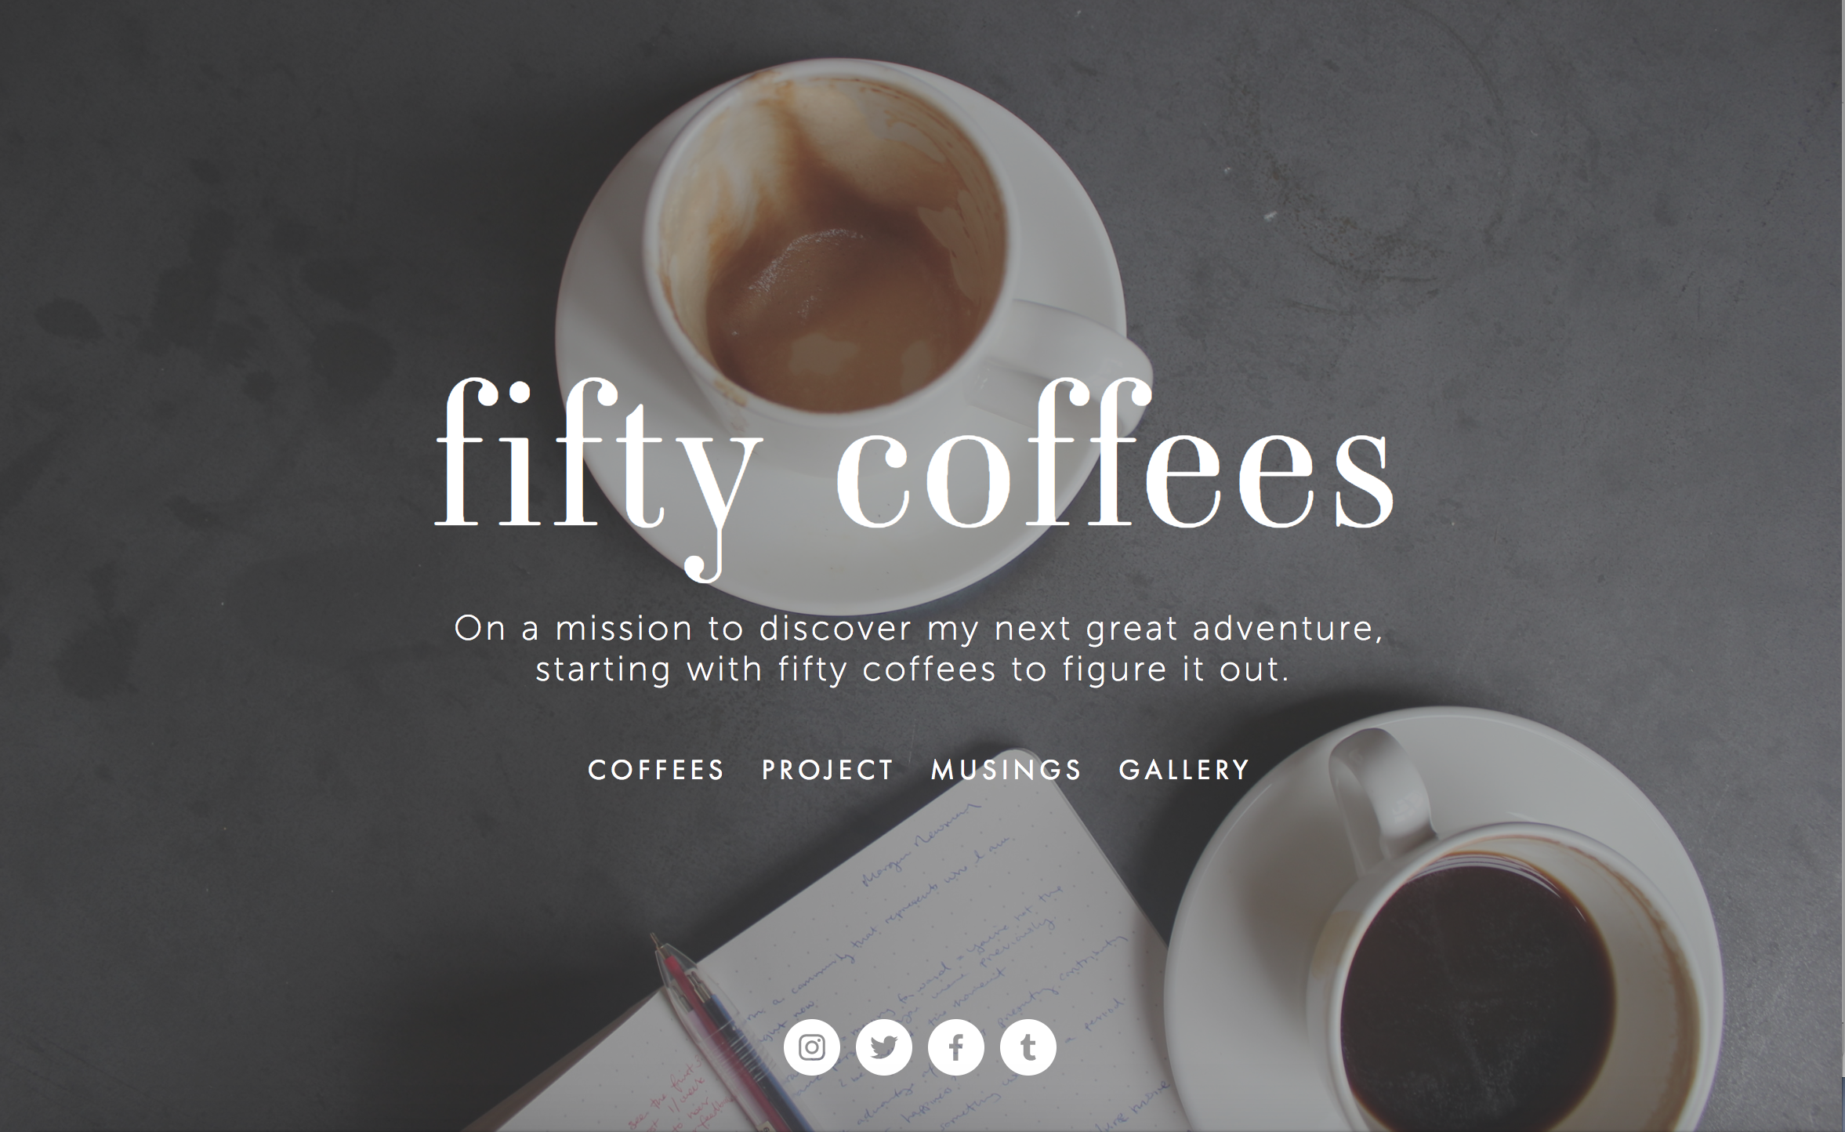 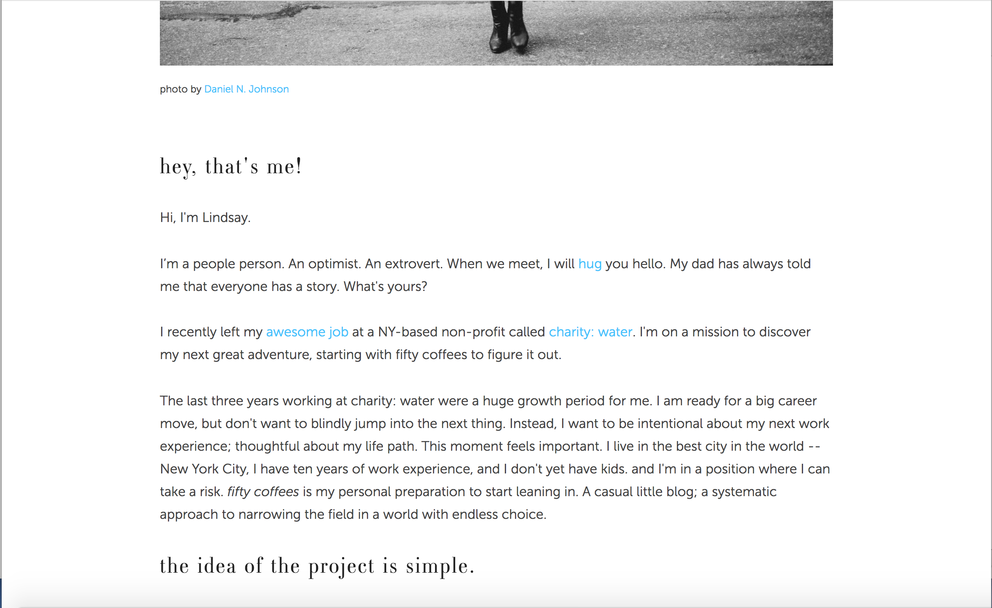

Although it does not even look like a personal website, it told me that good blog content can be an effective way to bring people to you and have them learn more about what you do.